AMICO Architectural Metal Systems Expanded Mesh General Specifications

Part 1: General Information
- Summary: This document includes general information about AMICO Architectural Metal Systems’ expanded mesh and perforated products. The information included in this document represents general practices in terms of fabrication and manufacturing, however as AMICO seeks to serve the custom needs of the designer, variation may exist on a project-by-project basis.
- Reference Standards: Work will comply with published recommendations of the following unless otherwise stated:
  - LEED – Leadership in Energy and Environmental Design.
  - EMMA 557 – Standards for Expanded Mesh
  - AAMA 2604 and 2605 High-Performance Coatings on Aluminum Panels
  - AAMA 609 and 610: Cleaning and Maintenance Guide for Architectural Finished Aluminum
  - AAMA 611: Voluntary Specification for Anodized Architectural Aluminum
  - IPA Specifiers and Buyers Handbook for Perforated Metal
- Submittals
  - Product Data: AMICO shop drawings will indicate final panel sizes.
  - Finish selection: AMICO will work with the designers to determine the best finish to meet their design goals. Finish swatches will come from the finish manufacturer. Finish on AMICO material samples are available upon request, at a fee, and can take 3-4 weeks to complete.
  - Samples:
    - Samples are available upon request.
    - Large-scale mockups are available upon request at a fee.
  - Shop Drawings: Submit electronic CAD files for detailing by AMICO including structural constraints for anchor placement. AMICO will provide preliminary shop drawings for design and final shop drawings based on as-built dimensions.
  - Technical Datasheet: Project-specific engineering certifications can be provided by the manufacturer at additional costs.
  - Closeout Submittals:
    - Warranty: Warranty document specified herein
    - Maintenance Instructions: Maintenance should follow AAMA 609, AAM 610, and any finish manufacturer requirements.
  - Sustainable Design Submittals (LEED Reports):
    - Typical manufacturing includes virgin aluminum, however, special projects requesting pre- and post-consumer recycled content is achievable upon request.
    - Expanded mesh is manufactured in Burlington Ontario and Iberville Quebec.
    - Perforated metal is manufactured in Rochester New York, Charlotte North Carolina, or Visalia California
    - Specification documents for each material can provide relevant documentation regarding the percentage of openness of perforations or expanded mesh as it relates to glare, heat gain, or energy consumption.
- Quality Assurance
  - Field Measurements: The contractor is responsible for providing the final as-built dimensions of the installation to ensure proper fit. At the contractor’s discretion, this may be field-verified dimensions and locations of structural members or connection points. Information must be supplied in a format acceptable to the manufacturer.
  - Installer Qualifications:
    - Company specializing in installing the work of the section with at least 5 years of documented experience with comparable-size projects.
    - Familiar with the products and the manufacturer’s installation method
  - Sourcing Limitations:
    - When possible, ensure all raw material for a single project came from the same producing mill, the same master slab, and the same chemical composition.
    - All panels of an installation shall be produced by the same manufacturer and finished by the same finish applicator to protect against variation.
- Delivery Storage and Handling
  - Delivery and Receipt
    - All crates and packaging should be inspected upon delivery for damage. Contact the manufacturer immediately at the time of receipt if any damage is identified. Photographs of any damaged product, including concealed damages, must be supplied to the manufacturer with any claims. Photos of damaged crates and packaging must also be provided to the manufacturer. Freight damage must be filed with the freight company within the freight carrier’s terms.
  - Storage and Transportation
    - Crated and palletized products that are stored under tarps should be frequently opened and ventilated to reduce humidity and condensation accumulation.
    - Do not lay any protective mats or covers directly on top of panels.
    - Do not store panels in contact with other materials that may cause staining, denting, or other surface damage.
    - Materials should not be kept in dusty environments that may result in particulate accumulation that could lead to surface scratching
    - Do not stack crates or pallets unless otherwise approved and noted by the manufacturer
    - Keep panels dry prior to installation
    - Materials should be kept in a secure location where mishandling and collisions cannot occur.
  - Handling Installation
    - Require all personnel to wear work clean gloves when handling and installing architectural metal panels.
    - Keep free of oil, grease, mortar, paint, acid, bitumen, drilling dust, dirty water, and other impurities.
    - Do not use adhesive tape on products in areas visible after installation.
    - Do not scribe or mark on visible surfaces of the product.
    - The contractor is responsible to usual all means necessary to protect the materials before during and after installation and to protect the instilled work and materials of all other trade activity.
    - Site conditions: Adjoining substrates and structures for attachment to be complete.
    - Replacement: In the event of damage, immediately make all repairs and replacements necessary at the sole cost of the responsible party.
- Warranty
  - Manufacturer’s Warranty: The products and materials are warranted to the finished product specification and to the physical and chemical properties of the raw material used if requested and expressly stated to AMICO prior to the sale.
    - The manufacturer will warrant its products to be of good quality, free from defects, in conformance with the specification, and when installed in accordance with the manufacturer’s published installation procedures.
    - This warranty is limited to 1-year from the date the product is purchased for its intended purpose.
    - Any defaults or defects in material or workmanship resulting solely from the manufacturer shall constitute a warranty claim.
    - AMICO makes no implied warranties including but not limited to the implied warranties of merchantability or fitness for a particular purpose. The exclusive remedy for any breach of warranty is replacement of the product or refund of the purchase price at Amico’s option.
    - Warranty Exclusions: The following are specifically excluded from the limited warranty.
      - Incidental cosmetic or consequential damages
      - Damage caused in shipment.
      - Damage resulting from acts of God, war, or riots.
      - Materials that have been altered after leaving an AMICO facility.
      - All repairs and replacement materials not authorized by AMICO.
      - Any labor cost incurred in removing or reinstalling AMICO materials.
      - Any warranty resolution not approved in writing in advance by AMICO.
  - Finish Applicator’s Warranty:
    - Finish warranty is tied to finish specification and warranty of finish manufacturer. Customer specifications should tie back to AAMA 2604 and 2605 standards.
    - This warranty does not cover natural weathering and fading of the surface that will occur as the surface is exposed to ambient conditions. Nor does it cover minor oxidation or oxidation products that transfer to other surfaces.

Part 2: Product
- Basis of Design: Expanded Mesh, perforated metal, attachment brackets, and/or fabricated elements such as frames are produced and distributed by AMICO
  - Website: www.AMICOARCH.com
  - Address: 1080 Corporate Drive, Burlington, ON Canada L7L 5R6
  - Contact: Phil Shevchenko – pshevchenko@amicoglobal.com
  - Phone: 905.741.7020
- Performance Criteria
  - Product shall utilize AMICO’s expanded mesh and perforated materials cut and fabricated to the design specifications of the customer and confirmed by AMICO shop drawings.
  - Tolerance: Panels and components shall be fabricated to a tolerance not exceeding 1/8” deviation in any dimension as shown in approved shop drawings
- Materials
  - This specification applies to AMICO expanded mesh and perforated metals including:
    - APEX01 Expanded Mesh
    - APEX02 Expanded Mesh
    - APEX03 Expanded Mesh
    - APEX04 Expanded Mesh
    - Bilbao Expanded Mesh
    - Crescent Expanded Mesh
    - Pisa Expanded Mesh
    - Sunshade Expanded Mesh
    - Venetian Expanded Mesh
    - Ripple Expanded Mesh
    - AMICO Perforated Metal including Picture PERFect Panels
  - These materials can be manufactured in various materials depending on the designer’s specifications.
    - Thickness: Various. Typically, 1/8” except for APEX02 which is 3/16”
    - Alloy: Various depending on desired finish and fabrication demands. Typically, aluminum 5005 O AQ, 3003 H14, 1100 H14, 1100 O Temper, Steel, Copper, Brass, and Corten.
    - Panel sizes: Custom per design. Maximum panel widths are shown below.
    - Panel depth: See individual spec sheets for details.
    - Finish: These materials are finished per the specification of the designer and are typically Fluoropolymer paint, powder coating, or anodized
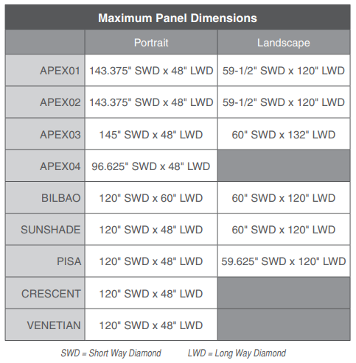
- Accessories
  - Attachment clips: Stainless Steel

Part 3: Execution:
- Site condition verification
  - Verify substruction suitability for attachment.
  - Suitable fasteners for attachment brackets is the responsibility of the contractor
  - Correct any conditions that may impede proper completion of work. The substructures must be plum & true, and capable of supporting the custom panels without deflection or deformation.
- Fabrication
  - Panels produced by AMICO will be in alignment with shop drawings and AMICOs tolerances limitations.
  - AMICO typically designs panel layouts with a 1/8” gap between panels to allow for expansion. AMICO drawings will ultimately guide the precise layout of panel spacing and attachment bracket layout.
- Site preparation
  - Anchor attachment points should be examined to ensure surfaces are clean and clear of obstacles and finished.
  - Ensure there is enough clearance in the surrounding area to allow for installers and materials to be lifted into place.
  - Installation
    - Comply with the panel manufacturer’s instructions for installation and assembly.
  - Tolerance
    - Attachment brackets typically have slots to allow for installation adjustments with 1/8” of play. When panels are attached, they can be subsequently adjusted within that range.
    - Panels should be installed plum and level as per shop drawings
    - Panel joints are typically have 1/8” gap designed into their placement +/- 1/6”
  - Cleaning and Protection
    - Maintain installed panels in a clean condition throughout construction and ensure that cleaning by other trades in proximity to the panels does not impart dust or debris. Avoid spilling, dripping, or splattering cleaning solutions onto panel surfaces.
    - Clean exposed surfaces of panels promptly after completion of installation. Comply with the recommendation of the panel manufacturer.
      - AAMA 609 and 610

APEX01 Portrait
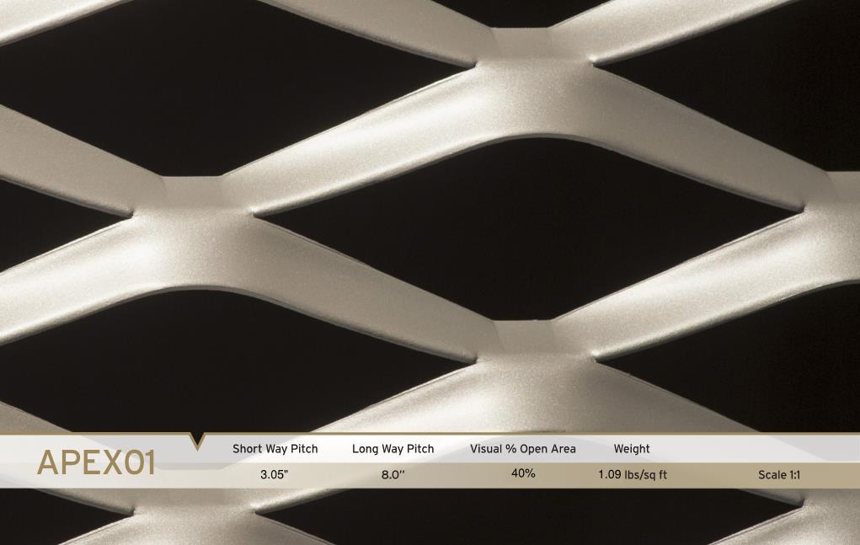
APEX02 Landscape
